Alcohol Consumption: Physiology and the Drinking Age

Alcohol consumption has been a part of human society almost since the dawn of civilization. The very first people to leave some uncovered grain jars outside when they went on a hunt were quick to discover and enjoy the positive effects of this primitive brew, but they did not realize that there was more to alcohol than the warm, fuzzy feelings it was quick to produce in them. Now, we have done much research into the physiological basis of alcohol’s function, and we appreciate that the world’s favorite drug has many unintended side effects. From limiting memory and decreasing nutrient absorption to inhibiting brain development during adolescence, there are certainly negative consequences to pursuing the positive feelings alcohol can produce. One of the main factors limiting access to this dangerous drug is the drinking age, but its establishment does not take into consideration the relevant facts about alcohol’s effects on the body throughout an individual’s life. Any discussion of a legal drinking age must involve an understanding of the impact of alcohol on the brain and the liver in adulthood and on development as an adolescent.

The first step in utilizing medical research to choose a drinking age is to consider the effects of alcohol use on the brain. Alcohol interacts with the brain in very many ways, all of which can have negative side effects on the health of the drinker. The first brain transmission system acted upon by alcohol is the opioid system. Alcohol acts as an opioid agonist, especially on mu and delta opioid receptors, to create the reinforcing effects of alcohol use (including pleasure, analgesia, and stress reduction). This was confirmed when trials of the drug naltrexone showed that administration of an opioid agonist helped reduce the occurrence of relapse following a single episode of drinking in abstinent alcoholics1.

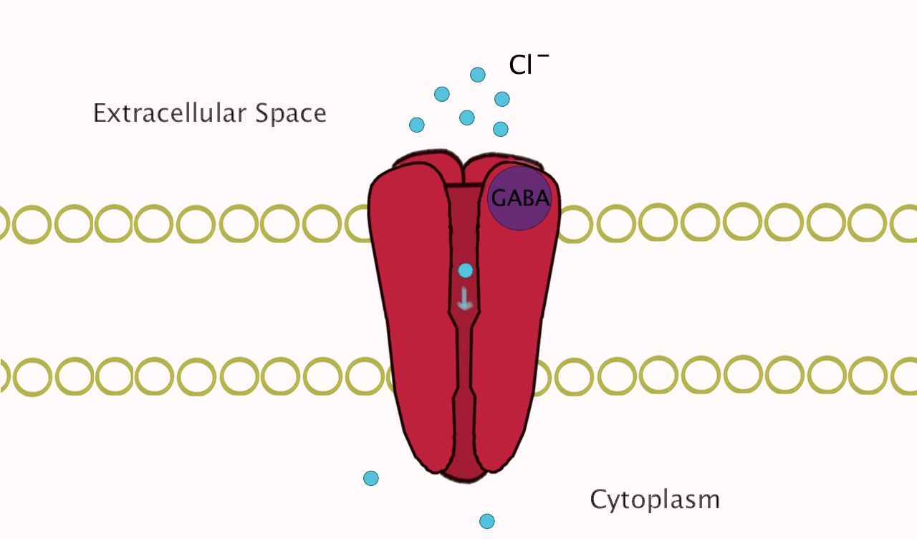 Along with acting as an opioid agonist, alcohol also interacts with the GABA inhibitory system. The GABA system is one of the most important inhibition mechanisms in the brain, causing many anti-anxiety effects, and it is thus the target of mot barbiturates and benzodiazepines2. GABA receptors function by opening an ion channel upon binding of GABA to permit Cl- ions to enter the cell, thereby reducing the cell’s excitability, decreasing the cell’s ability to pass on action potentials, and reducing anxiety2 (see Figure 1).

Figure 1: Normal GABA Receptor

At low to medium concentration, ethanol binds to one specific form (the long form) on one specific protein (GABAA) to cause an enlargement of this ion channel, and it thus enhances the action of GABA itself (Figure 2). At higher concentrations, however, the effects of ethanol are GABA-independent and can lead to a block of the excitability of neurons responsible for breathing2. This effect is one of the many ways high blood concentration of ethanol can be fatal.

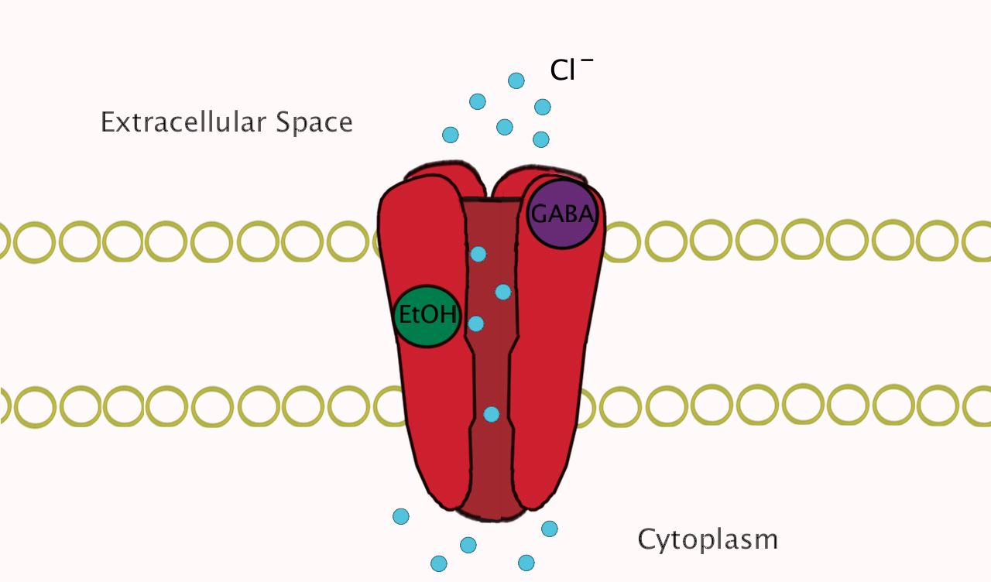

Figure 2: GABA Receptor with Bound EtOH

Along with increasing inhibitory processes in the brain, ethanol also decreases excitatory processes. One of the main excitatory transmitters in the brain is glutamate, and ethanol acts on NMDA receptors in such a way as to block the effects of glutamate. NMDA receptors are especially important in memory formation via long-term potentiation, and inhibiting this important process causes the amnesic effects of alcohol2. Naturally, the brain does not respond well to having such functions disturbed, so to allow the requisite amount of Ca++ to enter the cells, more NMDA channels are synthesized. This increase in channel number, along with a decrease in Mg+ concentration in typically dehydrated alcoholics has been shown to result in hyper-excitability of neurons, causing reactions (including strokes) in recovering alcoholics2. In a post-mortem study done on the brain tissue of individuals showing signs of alcohol abuse (liver cirrhosis, a measurable blood-alcohol content), quantities of GluR2 and GluR3, other important glutamate receptors, were found to be linked to the degree of alcoholism exhibited by each subject3. Thus, as an individual’s alcohol dependence increased, so did the number of NMDA and GluR2/3 channels required to keep the body functioning.

The final system affected by ethanol in the brain is serotonin. In a normal brain, serotonin has very many functions. Alcohol acts specifically on anti-anxiety effects and, at high concentrations, nausea induction2. Serotonin receptors have even been used as indicators as to what type of alcoholic an individual is: Type I alcoholics begin experiencing their addiction after age 25 and show high levels of stress caused by their increased amount of 5-HT serotonin receptors, while Type II alcoholics are characterized by early addiction onset and low impulse control most likely caused by their decreased levels of 5-HT receptors2. Type II individuals are led to drink by the same characteristic that causes their increased crime rates, their low levels of serotonin receptors, while Type I individuals are driven to drink to reduce the anxiety caused by their increased receptors.

Even though the most serious effects mentioned above are the result of heavy drinking and will not result from moderate alcohol consumption, the fact that so many negative impacts can happen shows that alcohol can be very dangerous in the brain. Ethanol impacts many important brain processes, and the effects are not limited to the duration of time when an individual is actively consuming alcohol. These effects, both short- and long-term, need to be accounted for when choosing a drinking age because their impact can cause such major problems as death by asphyxiation, memory loss, and decreased sensitivity to key neurotransmitters, leading to addiction.

Not only does alcohol affect the brain in many ways, but also other processes, including metabolism and liver function. As with ethanol’s impact on the brain, alcohol also affects metabolism in a plethora of different manners. The first of these is the most well-known - liver failure. Excess consumption of alcohol over time leads to cirrhosis of the liver, beginning with fat buildup caused by excess NAD reduction from free H+ production from the action of liver alcohol dehydrogenase (ADH)4. ADH essentially catalyzes an oxidation-reduction reaction that oxidizes ethanol to acetaldehyde and acetic acid and reduces NAD+ to NADH. When excess ethanol is present, ADH not only over-produces NADH, but also releases more free radicals, increasing the oxidative stress put on the liver. ADH also inhibits the DNA repair processes of a healthy cell, along with decreasing the efficiency of the electron transport chain, the key supplier of metabolic energy, by causing the buildup of excess acetaldehyde. All of these lead to a high amount of hepatocyte death. This cell death causes to an intense inflammatory response (alcoholic hepatitis), which can cause liver tissues to be replaced with collagen. This collagen buildup is scarring, and when scarring becomes severe, the liver is in a state of cirrhosis4. Once the liver is cirrhotic, there are many health consequences that may follow. First, the fibrinogen system responsible for clot destruction (thrombolysis) is significantly increased in patients with cirrhosis5. Also, due to the decreased blood flow through the now scarred tissue of the liver, individuals with alcoholic cirrhosis also exhibit decreased drug clearance6. This can cause numerous problems with treating other conditions, such as bacterial infections, that the individual may encounter later in life. Finally, alcoholic liver cirrhosis is a major risk factor in hepatocellular carcinoma7. Tests show that not only do individuals with cirrhosis have higher risks of developing hepatocellular carcinoma than their counterparts with non-cirrhotic livers, but that cirrhotic patients had a chance of liver cancer that grew linearly with the number of years with a diagnosis of cirrhosis7.

Liver damages from the above processes only lead to more problems with metabolism. Along with the process of replacing normal calories with calories from alcohol depriving drinkers of more nutrient-dense foods and leading to decreased protein, fat and vitamin consumption, liver damage actually inhibits the ability of the body to absorb or utilize many key nutrients. Studies have shown that animals absorb less protein from food after receiving a dose of ethanol, and drinkers who already have liver damage have defects in protein metabolism including decreased production of albumin, decreased urea production, and decreased metabolism of all aromatic amino acids8. Vitamin metabolism is also significantly impacted, as alcoholics show marked deficiencies in Vitamins B1, B2, B6, B12, and C, which correspond to increasing rates of alcohol consumption and decreasing rates of vitamin intake8. Not only are vitamin levels affected by decreased intake, but also by decreased ability of the liver to process them. Vitamin A levels were monitored in patients with liver damage, and it was found that, while these patients had normal levels of beta-carotene (a precursor to Vitamin A) in the blood, they had decreased levels of Vitamin A in the liver8. This proved that the damage done to these patients’ livers had caused a defect in their ability to produce the Vitamin A needed to maintain bone growth and eye function, most likely caused by a combination of increased Vitamin A secretion from the liver and up-regulation of the enzymes responsible for breaking down Vitamin A due to the presence of alcohol. As all of these examples, from liver cirrhosis to vitamin deficiencies, have shown, excess alcohol has a severely negative impact on metabolic function. Similarly to alcohol’s effects on the brain, however, these studies are only performed on patients who consume excess amounts of alcohol.

While a solid understanding of alcohol’s effects on the body is important to deciding a legal drinking age, what is most applicable is determining the age-related effects of these processes. The first thing to consider is that the short term effects felt by the drinker do not vary from childhood to adolescence to adulthood.The only difference is the decrease in amount of alcohol needed to initiate coma in very young children9, but this is to be expected, as a lower amount of ethanol would be needed to achieve similar blood concentration levels.

Unlike the short-term effects of alcohol use, however, the long-term effects can be significantly different between children and adults. The first such example can be found when examining the liver. While there are only slight increases in serum liver enzymes in patients with alcohol use disorders (AUDs), these small changes result in an overall increase in risk for liver damage later in life10. This means that individuals who begin drinking at an early age have a significantly greater risk of developing fatty liver, alcoholic hepatitis, alcoholic cirrhosis, and the subsequent metabolic disorders.

Another example of the long-term effects of alcohol on an individual still in adolescence is the impact ethanol has on brain development. It is widely believed that alcohol use during this formative period of life can have very harmful effects, and evidence supports this in three ways. First, there is a notable decrease in prefrontal white matter, the area of the brain largely responsible for decision-making, between children (age 17) with and without AUDs. The exact causal relationship of these observations is not known, however, and it is possible that decreased inhibition led to drinking problems, not vice versa11. Second, the hippocampus is completing its development during the time of adolescence. Largely responsible for new memory formation, volume of the hippocampus is found to be significantly lower in adolescents with AUDs than in those who do not drink or who imbibe more responsibly11. This decrease can lead to decreases in memory test scores, and the individual’s hippocampus will never fully develop. Finally, the amygdala is also in peak development in this part of a child’s life, and its total volume is also decreased in patients with AUDs11.

Perhaps as a direct result of the above-mentioned effects of ethanol on liver and brain development, adolescents with AUDs also experience many other health conditions. Self-reported general health issues were much higher in adolescents with AUDs than those without9, and these same adolescents also experience mental challenges as a result of their alcohol abuse. Studies have shown that adolescent AUD leads to exacerbation of existing mental conditions, as well as causing negative emotions, anxiety, and depression8. As if this weren’t bad enough, the same individuals can also expect mild impairment of neurological function, as measured by standardized performance tests10. Finally, adolescent AUD can lead to down-regulation of benzodiazepine receptors, which can then lead to increased dependence on alcohol later in life10.

There are indeed many harmful side effects of alcohol use in adulthood and adolescence, but there are a few problems with using this evidence to support the establishment of a legal drinking age. These studies are performed by observing adolescents and adults who already abuse alcohol. There is little evidence to support that moderate consumption puts teens at any more risk than their adult counterparts12, so it is difficult to say that developmental concerns should be a factor here. There is no evidential reason to believe that adolescents, given the proper education about alcohol use, would participate in improper use of this drug any more than would be expected for a population of any age group. Finally, development occurs at a different pace in different individuals. Mandating a legal drinking age based on developmental concerns would thus not be valid, as such an age would have to be old enough to protect even those with the slowest developmental process.

While it is impossible to say what the drinking age should be based on scientific evidence alone, it is clear that drinking can cause serious physiological damage. Any consideration for establishing a new drinking age, or even for keeping the current age of 21, must involve an understanding of the impact of alcohol on the brain, the liver, and in development if it is to be a useful tool in protecting American youth. The consequences of alcohol use and abuse are simply too serious to allow them to be ignored.

Sources

1. “Naltrexone and Coping Skills Therapy for Alcohol Dependence: a Controlled Study.” (Archives of General Psychology 1992 Vol. 49, 881-887.)
2. “Alcohol and the brain. Pharmacological insights for psychiatrists.” (British Journal of Psychiatry 1999 Vol. 175, 114-119.)
3. “Glutamate Receptor Subtype Expression in Human Postmortem Brain Tissue from Schizophrenics and Alcohol Abusers.” (Brain Research 1995 Vol. 674, 82-90.)
4. “Studies on Liver Alcohol Dehydrogenase” (Acta Chem Scand Vol. 7:9, 1148-1165)
5. “Abnormal Plasminogen-Plasmin System Activity (Fibrinolysis) in Patients with Hepatic Cirrhosis: Its Cause and Consequences.” (Journal of Clinical Investigation 1964 Vol. 43:4, 681-695.)
6. “The Hepatic Sinusoid in Aging and Cirrhosis: Effects on Hepatic Substrate Disposition and Drug Clearance.” (Clinical Pharmacokinetics 2005 Vol. 44:2, 187-200.)
7. “A Multivariate Analysis of Risk Factors for Hepatocellular Carcinogenesis: AProspective Observation of 795 Patients with Viral and Alcoholic Cirrhosis.” (Hepatology 1993 Vol. 18:1, 47-53.)
8. “Relationships Between Nutrition, Alcohol Use, and Liver Disease” (Alcohol Research and Health Vol. 27:3, 220-232)
9. “Alcohol Intoxication in Childhood and Adolescence” (Alcohol and Alcoholism Vol. 30:1, 5-12)
10. “The Natural History of Adolescent Alcohol Use Disorders” (Addiction Vol. 9:2, 5-22)
11. “Alcohol, Psychological Dysregulation, and Adolescent Brain Development” (Alcoholism: Clinical and Experimental Research Vol. 32:3, 375-385)
12. “Alcohol and the Adolescent Brain- Human Studies” (National Institute on Alcohol Abuse and Alcoholism)