The European Drinking Model: A Comparison with the United States

The drinking age in the United States has been a hot topic for decades. The drinking age was mainly raised to 21 in order to reduce the amount of alcohol related vehicular accidents, but there are still many people who believe that the minimum legal drinking age should be lowered. Although it is hard to predict what kind of changes will occur due to a lower drinking age in the United States, Europe has often been used as a model to understand the effects of a lower drinking age. While the minimum legal drinking age in the United States is 21, the drinking age in Europe is almost exclusively 16-18 years of age (“Global”). There are a number of arguments that support lowering the drinking age that center around Europe. It is a widespread belief that drinkers in Europe get into less alcohol related accidents, and practice overall safer drinking habits (“United States Federal”). While many of these arguments are commonly accepted, it is worthwhile to look deeper at the statistics to determine whether the European minimum legal drinking age model should be implemented in the United States. After analysis of these arguments it was found that the statistics that support them may not be strong enough to encourage adoption of the European drinking model in the United States.

An important argument that proponents of a lower drinking age have is that the amount of alcohol related vehicular accidents is significantly lower in Europe. Due to this fact, many believe that lowering the drinking age in the United States may also decrease these types of accidents. Studies have in fact found that about 1/3 of car accidents are alcohol related in the United States(“United States Department”), in comparison to only 1/4 in Europe (“Alcohol”). According to this data, there may be a large incentive for the U.S. to lower its drinking age in order to decrease the number of alcohol related car fatalities. What is important to remember is that there are many other factors that come into play when comparing Europe and the United States, and these factors may also have an effect on drinking related car accident statistics.

An important distinction to make between Europe and the U.S. is the access to, and use of, public transportation by its citizens. The mass transit system in Europe is far larger than the system in the United States. In large cities alone, public transportation accounts for about 20% of trips made in the U.S., while in Europe it accounts for over 50% (Oosterman). Why don’t Americans utilize public transportation? First of all, it is much more expensive for Americans to use public transportation than it is for them to drive their own cars (Oosterman). Secondly, aside from those individuals living in cities, access to public transportation is quite slim in the U.S., whereas in Europe there are a vast number of train and bus options throughout the continent. Not only is it cheaper for Americans to drive cars, but many Americans do not have the access to public transport that most Europeans have. This may have a large impact on the alcohol related vehicular accidents statistics.

A study done in 2009 at Cornell University found a correlation between access to public transportation and the likelihood that an individual drives drunk (Jackson). Public transport in the Washington D.C. area initially closed before the bars did, but in 2009 public transport was made available until after the closing time of bars. This allowed researchers to collect data before and after the time change. There was found to be a 7% decrease in DUI arrests in the D.C. area for every extra hour that public transportation remained open (Jackson). Considering that not all individuals who drive under the influence are actually pulled over, the percent decrease in number of drunk drivers could have been even greater than 7%. This study indicates that it is possible that the lower incidence of drunk driving accidents in Europe may be attributable to a greater access to public transportation, and not just a lower drinking age.

Another important factor to consider when comparing alcohol related driving accidents are the ages at which citizens are able to start driving. The driving age in almost all U.S. states is 16, whereas in most European countries the minimum driving age is 18 (“States Urged”). In the United States teens are able to drive about five years before they are able to drink. Teens in Europe are not able to drive until two years after, or around the same time as, they are allowed to start drinking. With 16 year old drivers getting into 10 times as many car accidents as 30-59 year olds, it shows that young drivers are at a serious risk for accidents (“States Urged”). If accident rates are significantly higher at 16 it makes sense that the U.S. would have greater alcohol related accident rates—Europeans cannot even drive at this age. While this assumption implies that 16 year olds in the United States must be drinking illegally in order to drive under the influence, it is no secret that underage drinking does happen. In fact, it is estimated that 1,900 Americans under 21 die each year due to underage drinking (“United States”). Lower driving ages in the United States and less access to public transportation are two factors that may affect the rate of alcohol related accidents in the United States. While there may be more incidences of alcohol related accidents in the U.S. than Europe, it is not safe to assume that this is only due to the higher drinking age.

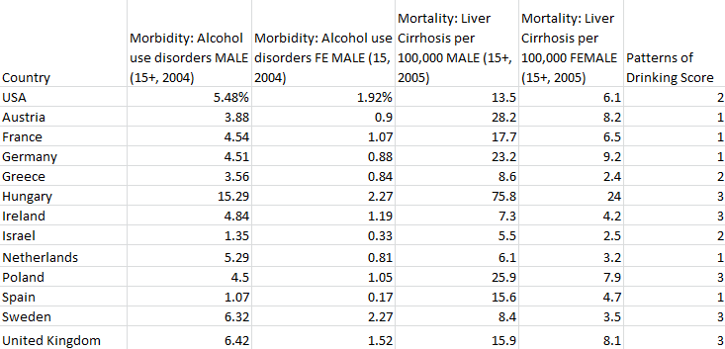Another important factor when determining whether the United States should lower the drinking age is health. Alcohol related health problems could possibly increase, or decrease, if the drinking age is lowered to 18. The World Health Organization has done extensive studies on drinking habits around the world. The figure below includes various alcohol related health statistics for 12 European countries and the U.S. All of the statistics have been gathered by the WHO. Three major areas of research were alcohol use disorders, liver cirrhosis, and patterns of drinking. For a 12-month prevalence in 2004 the morbidity rates of alcohol use disorders in the U.S. for males aged 15 and up was 5.48%. For females it was 1.92% (“Global”). Of the 12 European countries included in Table 1, seven had lower scores for both sexes and 2 had higher scores for both sexes. Three of the countries showed higher morbidity rates among males, but lower rates among females. Overall it seems that the United States may have a slightly higher morbidity rate of alcohol use disorders.

Table 1) Health problems associated with alcohol consumption around the world

The WHO also looked at liver cirrhosis mortality rates per 100,000 individuals aged 15 and above in 2005. There were an estimated 13.5 male deaths in the U.S., and 6.1 female deaths (“Global”). It seems that the U.S. falls somewhere in between the European countries. Six of the 12 European countries had higher rates, 5 had lower rates, and one had split rates for males and females (“Global”). Finally, the WHO assigned a “patterns of drinking score” to each country. The greater the pattern of drinking score, the greater the amount of alcohol-attributable health problems for a given country. The United States scored 2 out of 5 on this scale, with 5 being the most burdensome (“Global”). Again, the U.S. ends up somewhere in the middle of the pack. Five European countries were assigned a score of 1, five were assigned a score of 3, and two also scored a 2 (“Global”). It seems that from a health perspective according to this data, a drinking age of 16-18 versus 21 does not have a significant impact.

Another important argument that proponents have for lowering the drinking age is that it will make citizens much more responsible drinkers. Public officials, including a number of college presidents, see lowering the drinking age as a solution to the ever increasing binge drinking problem in the U.S. (Thomas). If teens are brought up drinking alcohol casually with their families, as are Europeans, it won’t seem like such a “forbidden fruit”(Friese). This is a very logical argument, so it may seem surprising that Europeans are not necessarily more responsible drinkers than Americans despite their lower drinking age. Not only this, but there is also a binge drinking problem in Europe as well. The Prevention Research Center of the Pacific Institute for Research and Evaluation conducted a number of studies in Europe and the U.S. in 2007. According to Figure 1, the U.S. has a lower percentage of 15-16 year olds reporting having drank alcohol within the past 30 days than all but one European country surveyed(Friese). From this data it is important to look a little bit further at the actual drinking ages of the European countries used in the study. The drinking age in a few of the countries is 16, which make it much more likely that the 16 year old population in these countries will be more likely to drink in the past 30 days than the United States 16 year old population. Despite this fact, more than half of the European countries surveyed have drinking ages 18 or above. While it may not be a proper comparison for those countries with drinking ages of 16, it can be seen that the U.S. would still have a lower percentage than at least half of the European countries surveyed.

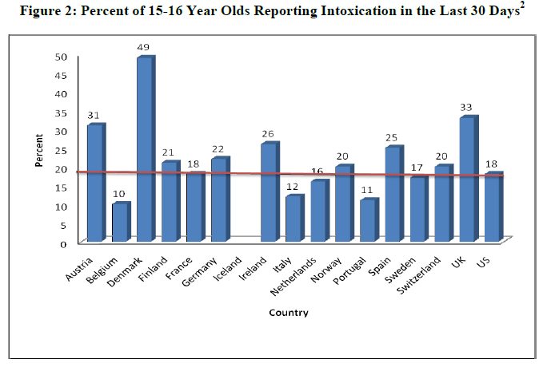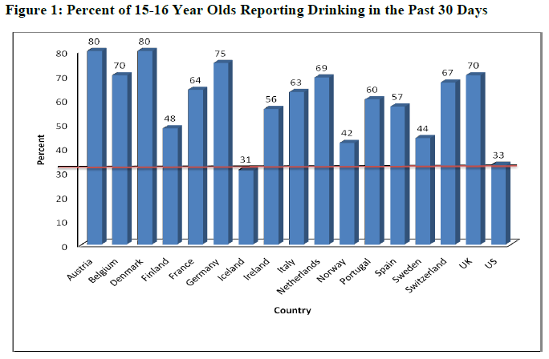Figure 2 shows percentage of 15-16 year olds reporting being intoxicated within the last 30 days. The United States appears to have equal if not slightly lower rates of intoxication in the last 30 days than most European countries (Friese). The intoxication studies are important because they help gauge drinking “responsibility”. Intoxication is a parameter used to gauge irresponsible drinking, so one would assume that if Europeans were in fact more responsible drinkers they would have lower intoxication rates. This is simply not the case. The Prevention Research Center of the Pacific Institute also looked at the percentage of 15-16 year old who have reported being intoxicated before the age of 13. Again, the U.S. 15-16 year old population reports a lower or equal percentage than all but three European countries surveyed (Friese).

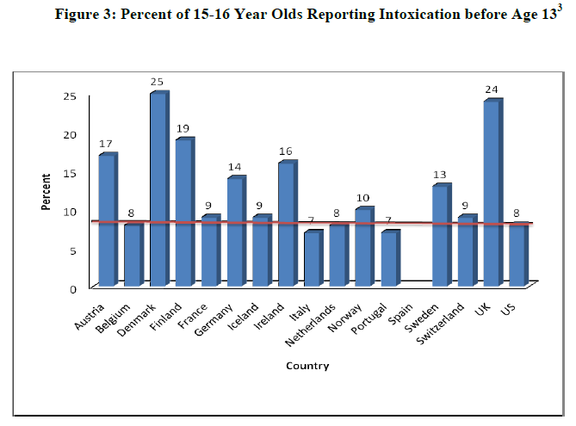Finally, there is a common understanding amongst supporters of lowering the drinking age that it may decrease the incidence of binge drinking in the United States. Binge drinking is an increasing problem in the United States, and has become even more dangerous now that kids are taking their binge drinking “underground” where they are less likely to be caught(Thomas). Over 150 college presidents met in 2008 to discuss the binge drinking problem on college campuses. They believe that the drinking age issue should be re-evaluated. They think it is possible that a lower drinking age may help curb binge and irresponsible drinking and cite the European drinking model as a source of support (Thomas). While many think the answer to this problem is to lower the drinking age, most people do not realize that binge drinking is becoming an increasingly greater problem in Europe as well. A study from the New York Times found that in the United States, about 28% of individuals 18-24 report binge drinking about four days per month (Parker-Pope). A study done on behalf of the Institute of Alcohol Studies in London found that 24% of 15-24 year olds in Europe report binge drinking within the past week (Anderson). The study also found that 18% of European 15-16 year olds report binge drinking 3-4 times in the past month (Anderson). The reality of the situation is that there is also a binge drinking problem in Europe where there is in fact a lower drinking age.

While many proponents of lowering the drinking age look to Europe as a positive example that the U.S. should follow, it is important to look at the arguments from all angles. It *is* possible that lowering the drinking age in the United States may have many positive effects; but there are many misconceptions about the drinking behaviors and consequences when comparing the United States and Europe. There are a significant number of differences between the U.S. and the various European countries, making it extremely difficult to predict that their drinking model will be successful (or unsuccessful) in the United States. In order to create a stronger argument to lower the drinking age it is necessary to take into account these vast number of differences—such as eating and exercising behaviors, dependence on other types of drugs, public transportation accessibility, etc—before making any sort of conclusion. It does not seem that the data as it is presented currently is strong enough support the implementation of the European drinking model in the United States.

References

*Alcohol Related Harm in Europe - Key Data*. Brussels: European Commission, 2006. Print.

Anderson, Peter. *Binge Drinking and Europe*. Hamm, Germany: German Center for Addiction Issues, 2008. Print.

Friese, Bettina, and Joel W. Grube. "Youth Drinking Rates and Problems: A Comparison of European Countries and the United States." *Pacific Institute for Research and Evaluation* (2011) Print.

*Global Status Report on Alcohol and Health [2011]*. Geneva: World Health Organization, 2011. Print.

Jackson, C. Kirabo, and Emily Greene Owens. "One for the Road: Public Transportation, Alcohol Consumption, and Intoxicated Driving." *Journal of Public Economics* 95.1-2 (2011): 106-21. Print.

Oosterman, Andre. "Public Transportation Thrives in Europe and Asia—why Not in the USA?" *EcoHearth* 29 Sept. 2010: Print.

Parker-Pope, Tara. "America's Drinking Binge." *New York Times* 11 Jan. 2012, Well sec.: Print.

States Urged to Raise the Driving Age." *CBSNews*. CBS Interactive Inc, 11 Feb. 2009. Print.

Thomas, Evan. "How to Fight Binge Drinking." *Newsweek* [New York City] 10 Sept. 2008: Print.

United States. Department of Health & Human Services. Centers for Disease Control and Prevention. *Injury Prevention and Control: Motor Vehicle Safety*. Atlanta: 2012. Print.

United States. Federal Trade Commision. *Dangers of Teen Drinking*. We Don't Serve Teens, n.d. Print.